**Batch T2**

**Assignment No. 12**

**Student Name: Pradum Yelame**

**Student PRN: 22510063**

1. Create one master city on the database

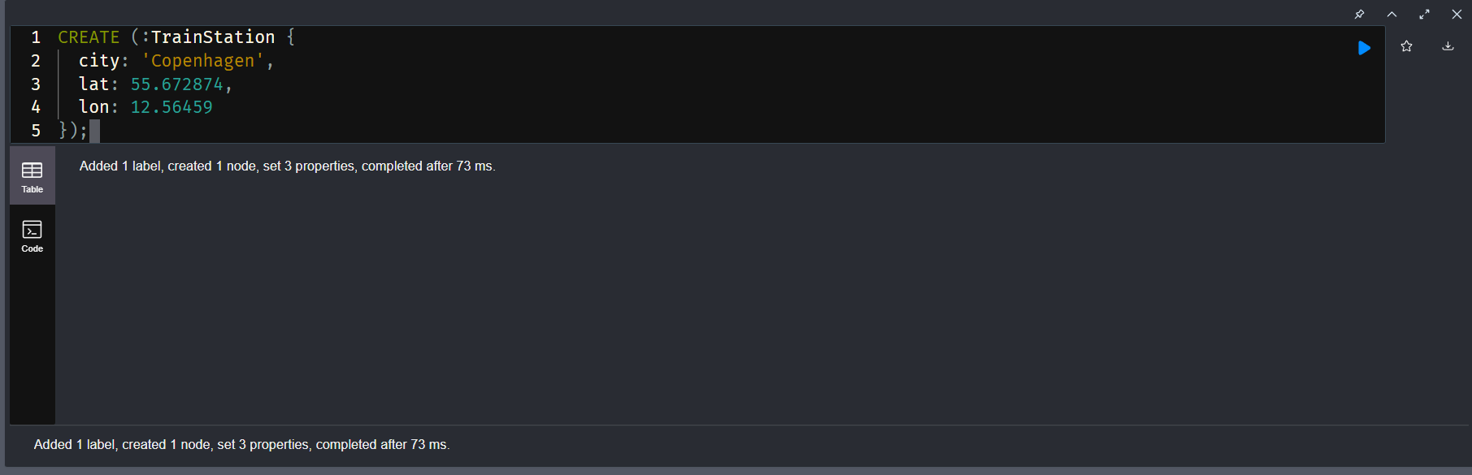

1. Second city

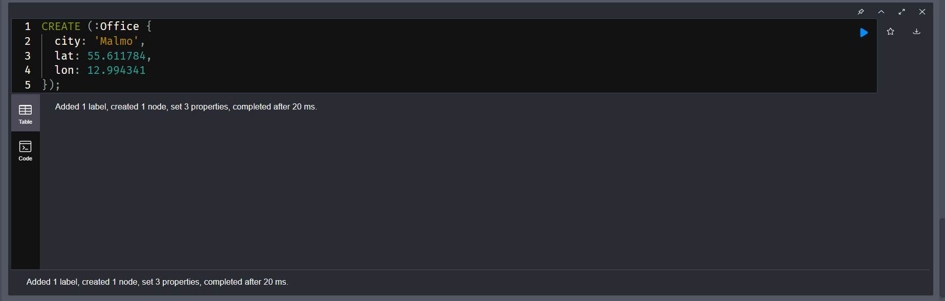

1. Create 10,000 Random Location Points

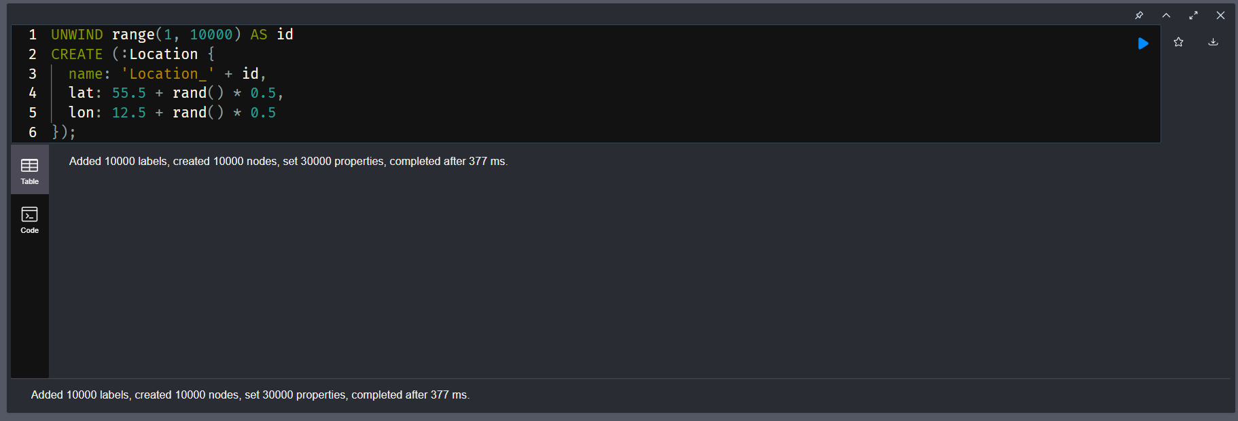

1. Find Nearby Locations Using point() and distance()

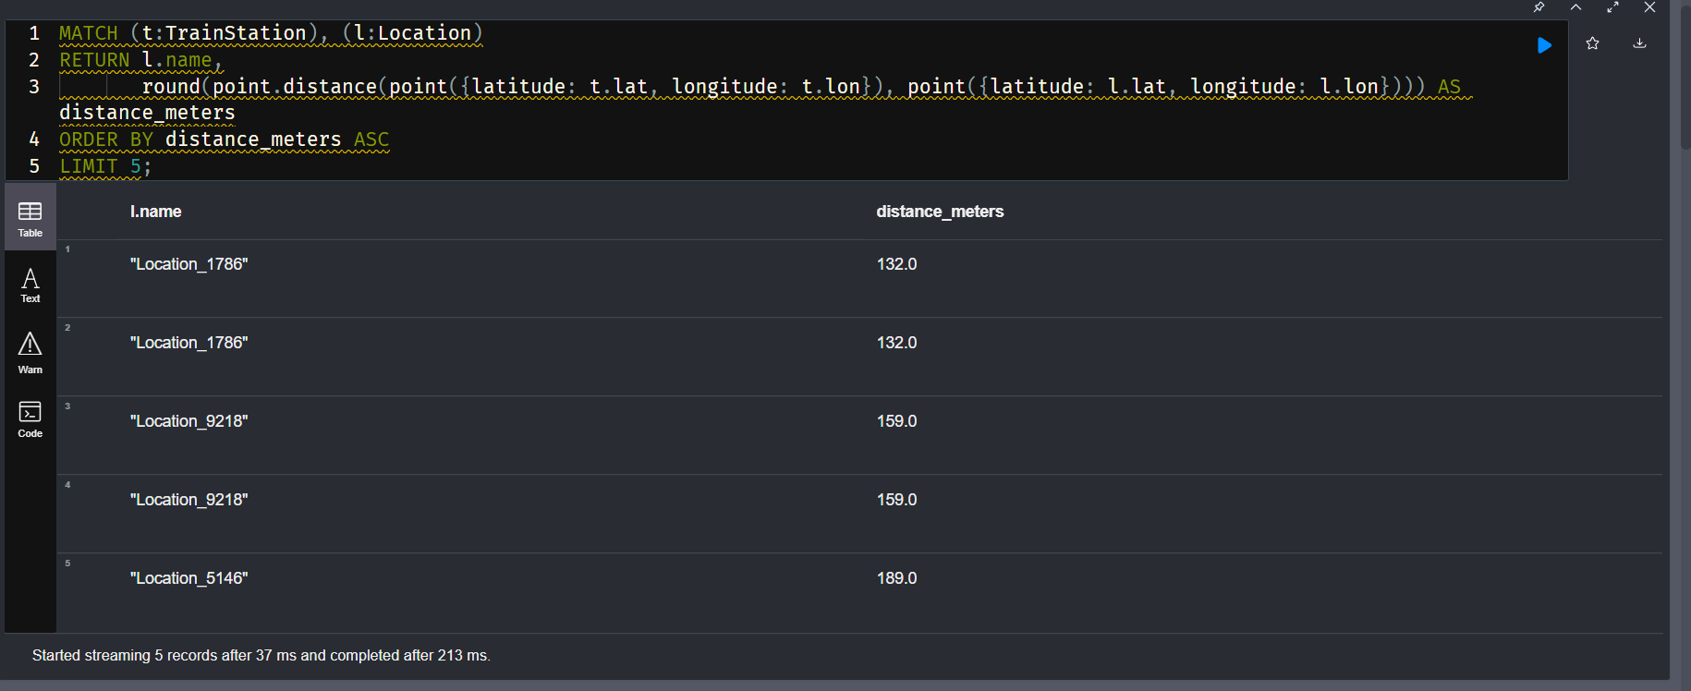

Demonstration Cypher Queries

**1. Add 10,000 Random Locations**

UNWIND range(1, 10000) AS id

CREATE (l:Location {

  id: id,

  name: 'Place ' + id,

  location: point({longitude: rand() * 360 - 180, latitude: rand() * 180 - 90})

});

2. Find 5 Nearest Locations to a Fixed Point (e.g., Pune)

WITH point({longitude: 73.8567, latitude: 18.5204}) AS pune

MATCH (l:Location)

RETURN l.name, point.distance(pune, l.location) AS dist

ORDER BY dist

LIMIT 5;

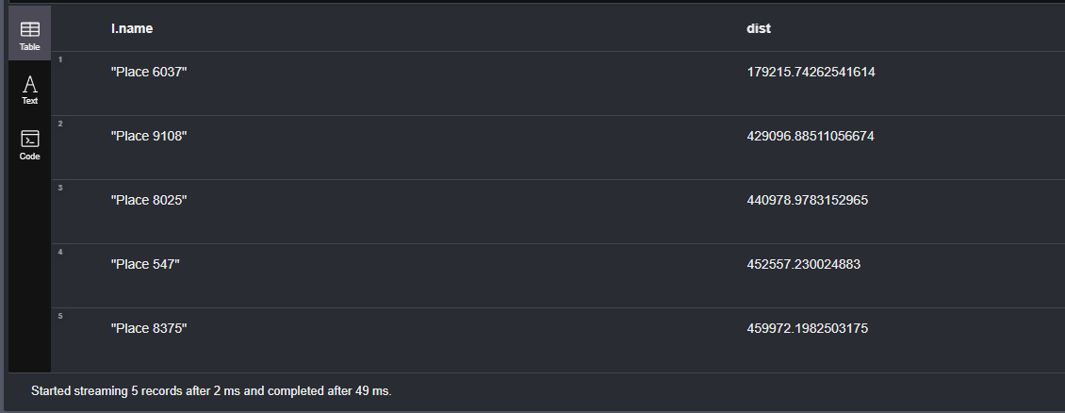

3. Find All Locations Within 100 Kilometers of Mumbai

WITH point({longitude: 72.8777, latitude: 19.0760}) AS mumbai

MATCH (l:Location)

WHERE point.distance(mumbai, l.location) < 100000

RETURN l.name, point.distance(mumbai, l.location) AS dist

ORDER BY dist;

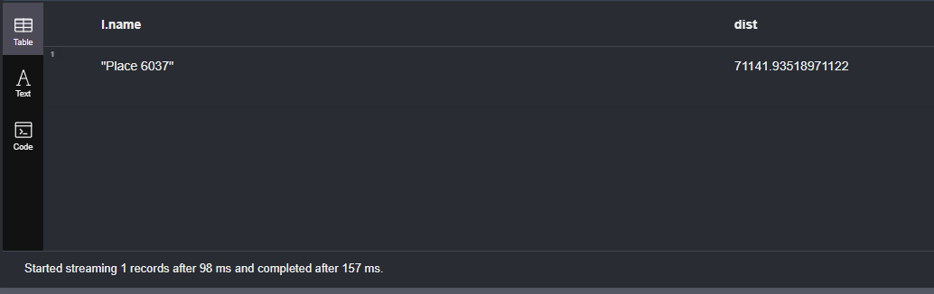

4. Find All Pairs of Locations Less Than 5km Apart

MATCH (a:Location), (b:Location)

WHERE id(a) < id(b) AND point.distance(a.location, b.location) < 5000

RETURN a.name AS Place1, b.name AS Place2, point.distance(a.location, b.location) AS dist

LIMIT 10;

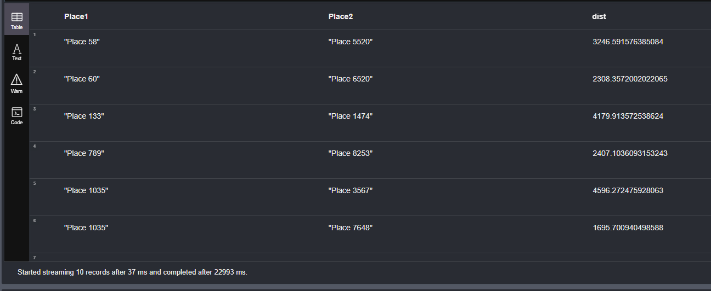

5. Find the Farthest Location from a Fixed Point

WITH point({longitude: 77.5946, latitude: 12.9716}) AS bangalore

MATCH (l:Location)

RETURN l.name, point.distance(bangalore, l.location) AS dist

ORDER BY dist DESC

LIMIT 1;

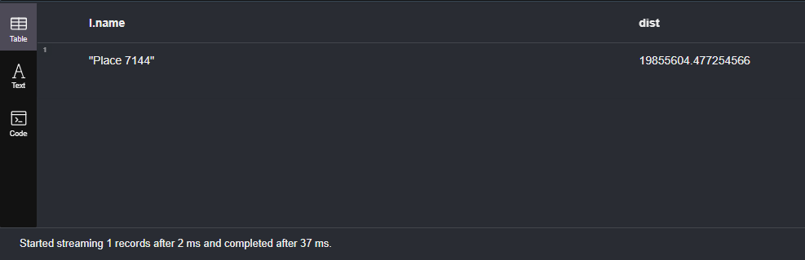

6. Average Distance of All Locations from Delhi

WITH point({longitude: 77.1025, latitude: 28.7041}) AS delhi

MATCH (l:Location)

RETURN avg(point.distance(delhi, l.location)) AS avgDistanceInMeters;

